OFAC’s Sanctions List Service
Basic Application Programing Interface (API) Documentation

An application program interface is a mechanism that allows users to run multiple information systems to communicate, often in an automated or scripted fashion. OFAC’s Sanctions List Service (SLS) supports API “get” commands that allow users to bypass the SLS user interface and retrieve sanctions list data directly from SLS’ backend databases.
OFAC understands that many users of its data are members of the sanctions compliance community, and that automated screening is a key compliance function in multiple industries. The SLS API allows users to automate their data pulls from the SLS application. Before OFAC developed a list management application with API support, users of OFAC data had to download an entire sanctions list and process those data on the user end. The Get commands that the SLS API supports allow users to choose which list they want to download or which part of a list they want to download. Users can choose to make these API requests as frequently as they would like. The following commands are supported by the SLS API.
SLS Public External APIs
Entities
- GET https://sanctionslistservice.ofac.treas.gov/entities
- GET https://sanctionslistservice.ofac.treas.gov/entities/{entity-id}
- GET https://sanctionslistservice.ofac.treas.gov/entities?list={list-name}
- GET https://sanctionslistservice.ofac.treas.gov/entities?program={program-name}
- GET https://sanctionslistservice.ofac.treas.gov/entities?list={list-name}&program={program-name}
Files
- GET https://sanctionslistservice.ofac.treas.gov/api/download/{filename}
List
- GET https://sanctionslistservice.ofac.treas.gov/changes/latest
- GET https://sanctionslistservice.ofac.treas.gov/changes/{publication-id}
- GET https://sanctionslistservice.ofac.treas.gov/changes/history/{year}
- GET https://sanctionslistservice.ofac.treas.gov/changes/history/{year}/{month}
- GET https://sanctionslistservice.ofac.treas.gov/changes/history/{year}/{month}/{day}
- GET https://sanctionslistservice.ofac.treas.gov/sanctions-lists
- GET https://sanctionslistservice.ofac.treas.gov/sanctions-programs
Customized Sanction Dataset
- GET https://sanctionslistservice.ofac.treas.gov/api/Customize/GetCustomizeList
Utility
- GET https://sanctionslistservice.ofac.treas.gov/alive
Entities
GET https://sanctionslistservice.ofac.treas.gov/entities
Description: Retrieves meta data related to a collection of entities based on either the entity Id, program, or sanction list
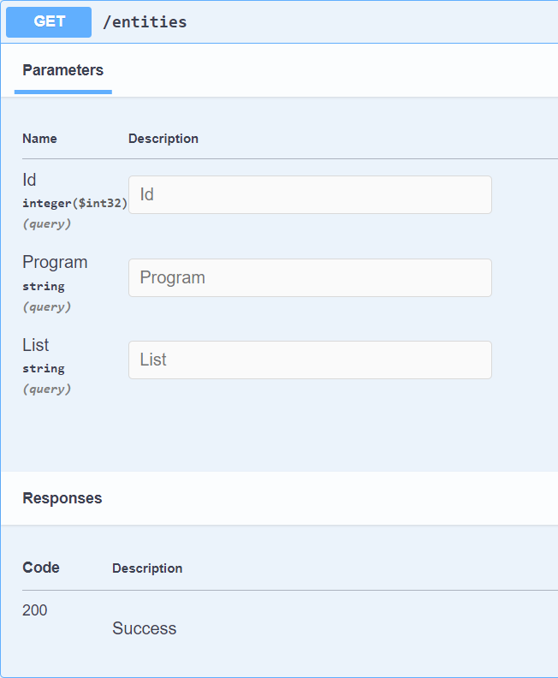

curl -X 'GET' \
'https://sanctionslistservice.ofac.treas.gov/entities?Id=30629&Program=CUBA' \
-H 'accept: */*'

Request URL
https://sanctionslistservice.ofac.treas.gov/entities?Id=30629&Program=CUBA

GET https://sanctionslistservice.ofac.treas.gov/entities/{entity-id}
Description: Retrieves meta data related an entity based on the entity Id
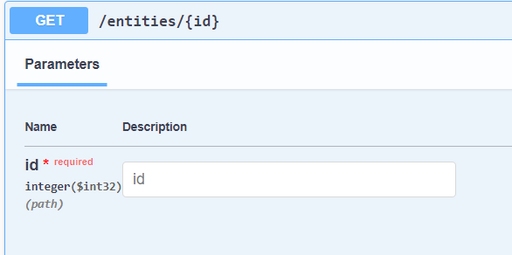

Curl
curl -X 'GET' \
'https://sanctionslistservice.ofac.treas.gov/entities/30629' \
-H 'accept: */*'

Request URL
https://sanctionslistservice.ofac.treas.gov/entities/30629

Server response
<?xml version="1.0" encoding="utf-8"?>
<entities>
<entity id="30629">
<generalInfo>
<identityId>22313</identityId>
<entityType refId="601">Entity</entityType>
</generalInfo>
<sanctionsLists>
<sanctionsList refId="1550" id="31269" datePublished="2020-12-21">SDN List</sanctionsList>
</sanctionsLists>
<sanctionsPrograms>
<sanctionsProgram refId="202" id="33166">CUBA</sanctionsProgram>
</sanctionsPrograms>
<sanctionsTypes>
<sanctionsType refId="1705" id="22787">Block</sanctionsType>
</sanctionsTypes>
<legalAuthorities>
<legalAuthority refId="91707" id="19621">Cuban Assets Control Regulations (CACR)</legalAuthority>
</legalAuthorities>
<names>
<name id="48173">
<isPrimary>true</isPrimary>
<isLowQuality>false</isLowQuality>
<translations>
<translation id="42433">
<isPrimary>true</isPrimary>
<script refId="20122">Latin</script>
<formattedLastName>KAVE COFFEE S.A.</formattedLastName>
<formattedFullName>KAVE COFFEE S.A.</formattedFullName>
<nameParts>
<namePart id="82583">
<type refId="1521">First Name</type>
<value>Alaa</value>
</namePart>
<namePart id="82582">
<type refId="1520">Last Name</type>
<value>AL-SAMAHI</value>
</namePart>
<namePart id="82584">
<type refId="1522">Middle Name</type>
<value>Ali Ali Mohammed</value>
</namePart>
</nameParts>
</translation>
</translations>
</name>
<name id="48700">
<isPrimary>false</isPrimary>
<aliasType refId="1400">A.K.A.</aliasType>
<isLowQuality>false</isLowQuality>
<translations>
<translation id="43088">
<isPrimary>true</isPrimary>
<script refId="20122">Latin</script>
<formattedFirstName>Allaa</formattedFirstName>
<formattedLastName>AL-SAMAHY</formattedLastName>
<formattedFullName>AL-SAMAHY, Allaa</formattedFullName>
<nameParts>
<namePart id="82586">
<type refId="1521">First Name</type>
<value>Allaa</value>
</namePart>
<namePart id="82585">
<type refId="1520">Last Name</type>
<value>AL-SAMAHY</value>
</namePart>
</nameParts>
</translation>
</translations>
</name>
</names>
<addresses>
<address id="46835">
<country refId="11205">Turkey</country>
<translations>
<translation id="40943">
<isPrimary>true</isPrimary>
<script refId="20122">Latin</script>
</translation>
</translations>
</address>
</addresses>
<features>
<feature id="39086">
<type featureTypeId="8">Birthdate</type>
<versionId>36805</versionId>
<value>08 Sep 1976</value>
<valueDate id="53731">
<fromDateBegin>1976-09-08</fromDateBegin>
<fromDateEnd>1976-09-08</fromDateEnd>
<toDateBegin>1976-09-08</toDateBegin>
<toDateEnd>1976-09-08</toDateEnd>
<isApproximate>false</isApproximate>
<isDateRange>false</isDateRange>
</valueDate>
<isPrimary>true</isPrimary>
</feature>
<feature id="39087">
<type featureTypeId="8">Birthdate</type>
<versionId>36806</versionId>
<value>1981</value>
<valueDate id="53732">
<fromDateBegin>1981-01-01</fromDateBegin>
<fromDateEnd>1981-01-01</fromDateEnd>
<toDateBegin>1981-12-31</toDateBegin>
<toDateEnd>1981-12-31</toDateEnd>
<isApproximate>false</isApproximate>
<isDateRange>false</isDateRange>
</valueDate>
<isPrimary>false</isPrimary>
</feature>
<feature id="39088">
<type featureTypeId="224">Gender</type>
<versionId>36807</versionId>
<value>Male</value>
<valueRefId>91526</valueRefId>
<isPrimary>true</isPrimary>
</feature>
</features>
</entity>
</entities>

GET https://sanctionslistservice.ofac.treas.gov/entities?list={list-name}
Description: Retrieves meta data related to a collection of entities based on the sanction list provided.

GET https://sanctionslistservice.ofac.treas.gov/entities?program={program-name}
Description: Retrieves meta data related to a collection of entities based program name provided.

GET https://sanctionslistservice.ofac.treas.gov/entities?list={list-name}&program={program-name}
Description: Retrieves meta data related to a collection of entities based on the sanction list and program name provided.
File Download API Calls
GET https://sanctionslistservice.ofac.treas.gov/api/download/{filename}
Description: Retrieves export flies based on file name
Files Available:
SDN_ENHANCED.ZIP | CONS_ENHANCED.ZIP
SDN_ENHANCED.XML | CONS_ADVANCED.ZIP
SDN_ADVANCED.XML | CONS_ENHANCED.XML
SDN_ADVANCED.ZIP | CONS_ADVANCED.XML
SDN.XML.ZIP | CONSOLIDATED.XML
SDN.XML | CONSOLIDATED.ZIP
SDN.CSV | CONS_PRIM.CSV
ADD.CSV | CONS_ADD.CSV
ALT.CSV | CONS_ALT.CSV
SDN_COMMENTS.CSV | CONS_COMMENTS.CSV
SDN.FF | CONS_PRIM.FF
ADD.FF | CONS_ADD.FF
ALT.FF | CONS_ALT.FF
SDN_COMMENTS.FF | CONS_COMMENTS.FF
List API Calls
The following API calls retrieve information on metadata for list changes, publication information for each list, and the Sanction List delta files based on publication id.

GET https://sanctionslistservice.ofac.treas.gov/changes/latest
Description: The following API call retrieves the latest published Sanction List delta file in xml format
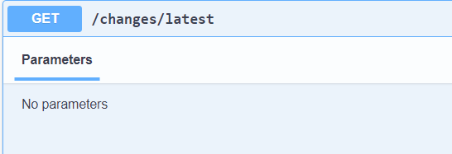

Curl
curl -X 'GET' \
'https://sanctionslistservice.ofac.treas.gov/changes/latest' \
-H 'accept: */*'

Request URL
https://sanctionslistservice.ofac.treas.gov/changes/latest

GET https://sanctionslistservice.ofac.treas.gov/changes/{publication-id}

Description: The following API call returns a sanction list delta file based on a publication unique id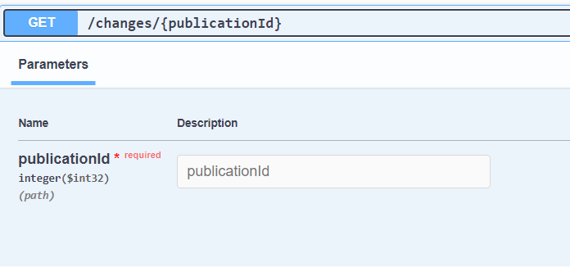

Curl
curl -X 'GET' \
'https://sanctionslistservice.ofac.treas.gov/changes/1' \
-H 'accept: */*'

Request URL
https://sanctionslistservice.ofac.treas.gov/changes/1

Server response

GET https://sanctionslistservice.ofac.treas.gov/changes/history/{year}
Description: The following API call retrieves a list of publications based on year

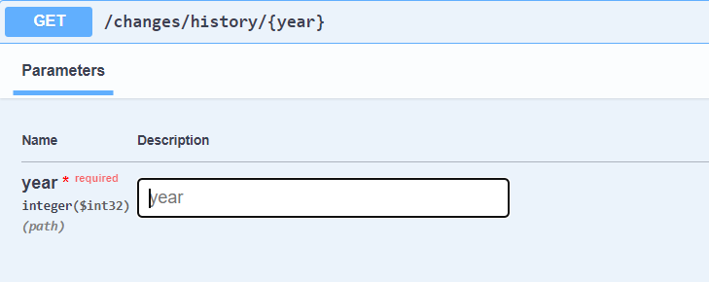

Curl
curl -X 'GET' \
'https://sanctionslistservice.ofac.treas.gov/changes/history/2024' \
-H 'accept: */*'

Request URL
https://sanctionslistservice.ofac.treas.gov/changes/history/2024

Response body
[
{
"publicationID": 1,
"datePublished": "2024-03-04T12:55:54.171841"
},
{
"publicationID": 2,
"datePublished": "2024-03-04T13:06:50.615692"
},
{
"publicationID": 3,
"datePublished": "2024-03-04T15:41:59.142461"
},
{
"publicationID": 4,
"datePublished": "2024-03-04T15:47:38.320062"
},
{
"publicationID": 5,
"datePublished": "2024-03-04T15:56:40.553935"
}
]

GET https://sanctionslistservice.ofac.treas.gov/changes/history/{year}/{month}
Description: The following API call retrieves a list of publications based on year and month

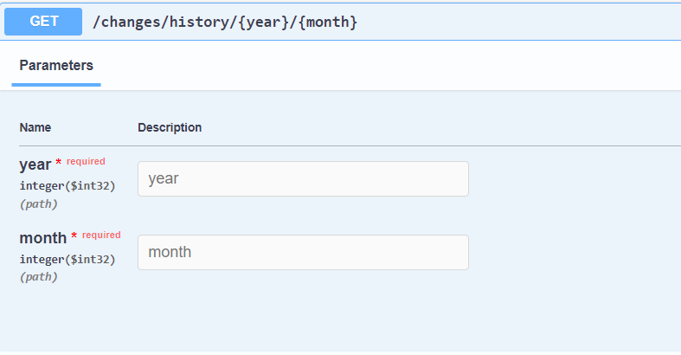

Curl
curl -X 'GET' \
'https://sanctionslistservice.ofac.treas.gov/changes/history/2024/02' \
-H 'accept: */*'

Request URL
https://sanctionslistservice.ofac.treas.gov/changes/history/2024/02

[
{
"publicationID": 1,
"datePublished": "2024-03-04T12:55:54.171841"
},
{
"publicationID": 2,
"datePublished": "2024-03-04T13:06:50.615692"
},
{
"publicationID": 3,
"datePublished": "2024-03-04T15:41:59.142461"
}
]

GET https://sanctionslistservice.ofac.treas.gov/changes/history/{year}/{month}/{day}
Description: The following API call retrieves a list of publications based on year, month, and day
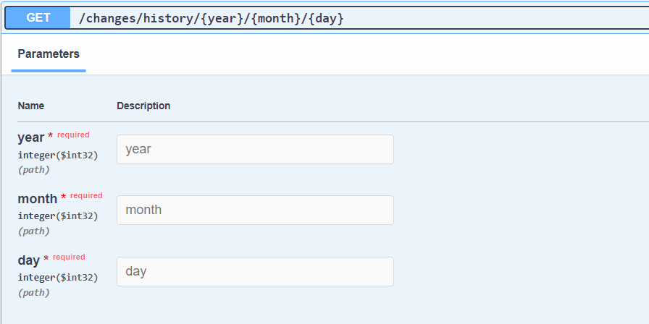

Curl
curl -X 'GET' \
'https://sanctionslistservice.ofac.treas.gov/changes/history/2024/03/04' \
-H 'accept: */*'

Request URL
https://sanctionslistservice.ofac.treas.gov/changes/history/2024/03/04

[
{
"publicationID": 1,
"datePublished": "2024-03-04T12:55:54.171841"
},
{
"publicationID": 2,
"datePublished": "2024-03-04T13:06:50.615692"
},
{
"publicationID": 3,
"datePublished": "2024-03-04T15:41:59.142461"
}
]

GET https://sanctionslistservice.ofac.treas.gov/sanctions-lists
Description: The following API call retrieves all sanction list names
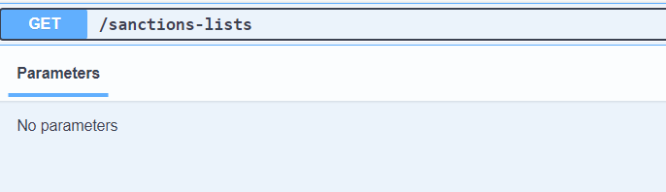

Curl
curl -X 'GET' \
'https://sanctionslistservice.ofac.treas.gov/sanctions-lists' \
-H 'accept: */*'

Request URL
https://sanctionslistservice.ofac.treas.gov/sanctions-lists

Response body

[
"SDN List",
"Non-SDN Palestinian Legislative Council List",
"FSE List",
"Sectoral Sanctions Identifications List",
"Consolidated List",
"CAPTA List",
"Non-SDN Menu-Based Sanctions List",
"Non-SDN CMIC List"
]

GET https://sanctionslistservice.ofac.treas.gov/sanctions-programs
Description: The following API call retrieves all sanction program names
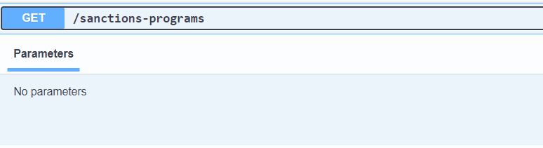

Curl
curl -X 'GET' \
'https://sanctionslistservice.ofac.treas.gov/sanctions-programs' \
-H 'accept: */*'

Request URL
https://sanctionslistservice.ofac.treas.gov/sanctions-programs

Response Body
[
"CUBA",
"SDNTK",
"FTO",
"IRAN",
"SDGT",
"SDNT",
"SYRIA",
"ZIMBABWE",
"IRAQ2",
"BALKANS",
"NPWMD",
"NS-PLC",
"BELARUS",
"DRCONGO",
"DARFUR",
"IRAQ3",
"LEBANON",
"SOMALIA",
"IRGC",
"IFSR",
"DPRK",
"IRAN-HR",
"LIBYA2",
"ISA",
"TCO",
"HRIT-SY",
"HRIT-IR",
"FSE-SY",
"FSE-IR",
"YEMEN",
"IRAN-TRA",
"MAGNIT",
"IFCA",
"UKRAINE-EO13660",
"CAR",
"SOUTH SUDAN",
"UKRAINE-EO13661",
"UKRAINE-EO13662",
"LIBYA3",
"DPRK2",
"UKRAINE-EO13685",
"VENEZUELA",
"DPRK3",
"CYBER2",
"DPRK4",
"GLOMAG",
"CAATSA - IRAN",
"CAATSA - RUSSIA",
"ELECTION-EO13848",
"NICARAGUA",
"VENEZUELA-EO13850",
"561-Related",
"IRAN-EO13871",
"NICARAGUA-NHRAA",
"DPRK-NKSPEA",
"IRAN-EO13876",
"MALI-EO13882",
"IRAN-EO13846",
"HIFPAA",
"SYRIA-EO13894",
"VENEZUELA-EO13884",
"IRAN-EO13902",
"ILLICIT-DRUGS-EO14059",
"SYRIA-CAESAR",
"HK-EO13936",
"IRAN-CON-ARMS-EO",
"PEESA",
"BURMA-EO14014",
"RUSSIA-EO14024",
"CMIC-EO13959",
"PEESA-EO14039",
"BELARUS-EO14038",
"BALKANS-EO14033",
"ETHIOPIA-EO14046",
"SSIDES",
"RUSSIA-EO14065",
"HOSTAGES-EO14078",
"UHRPA",
"SUDAN-EO14098",
"BPI-RUSSIA-EO14024",
"WEST-BANK-EO14115"
]

Customized Sanction Dataset
GET https://sanctionslistservice.ofac.treas.gov/api/Customize/GetCustomizeList
Description: The following API call retrieves an xml file containing all entities based on the provided parameters of publication date and sanction list type of SDN or CONS(Consolidated List)
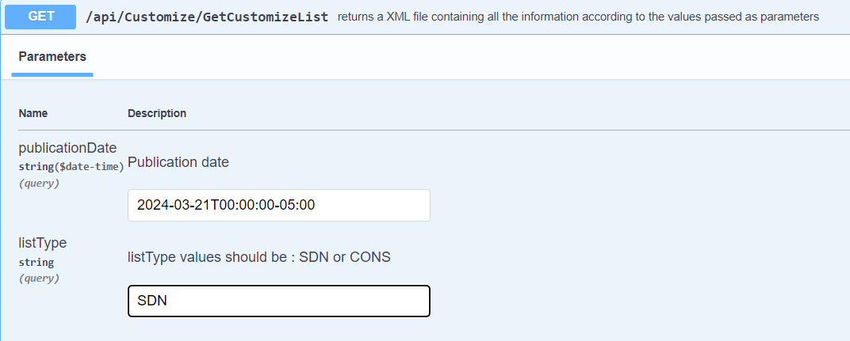

GET
Description: The following API call provides a health status of the Sanction List API

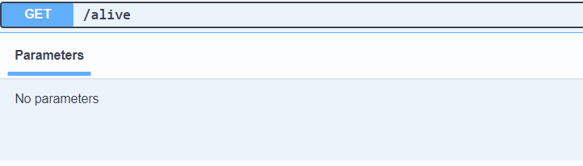

Curl
curl -X 'GET' \
'https://sanctionslistservice.ofac.treas.gov/alive' \
-H 'accept: */*'

Request URL
https://sanctionslistservice.ofac.treas.gov/alive
Response
200 HTTP Status code

